Geo-information Science and Remote Sensing
Thesis Report GIRS-2024-xx

Moose Habitat Selection and Movement
Dynamics in a Changing Thermal Landscape
under Climate Change
Accounting for circadian rhythmicity using harmonic terms
Niels van der Vegt

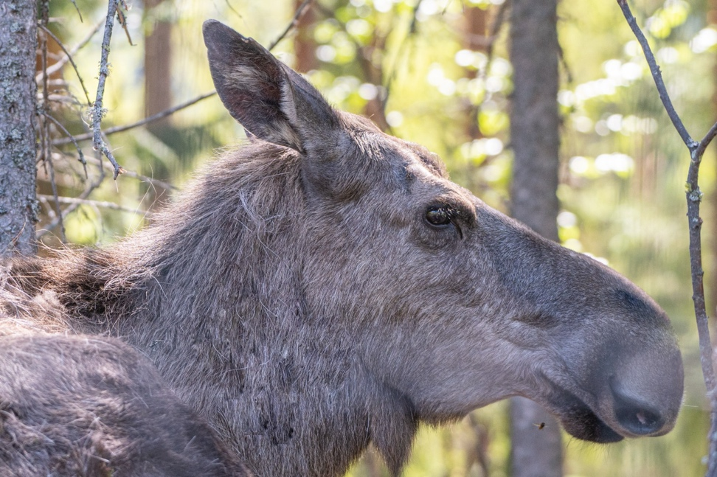

22 May 2025



Moose Habitat Selection and Movement Dynamics in a Changing Thermal Landscape under Climate Change
Accounting for circadian rhythmicity using harmonic terms

Niels van der Vegt

Registration number 1163116

Supervisors:

Sytze de Bruin, Wageningen University
Wiebke Neumann, Swedish University of Agricultural Sciences

A thesis submitted in partial fulfilment of the degree of Master of Science
at Wageningen University and Research,
The Netherlands.

22 May 2025
Wageningen, The Netherlands

Thesis code number: GRS-80436
Thesis Report: GIRS-2024 -xx
Wageningen University and Research
Laboratory of Geo-Information Science and Remote Sensing

Forword
I would like to thank my Oma Margreet for inspiring my fascination with the natural world. Her quiet appreciation for the beauty in the smallest things, the curve of different autumn leaves, rustle of grasses along the IJsel, chirp of the canary in the kitchen, and the delicate flowers she pressed between pages, taught me to look closely and care deeply.
One day, she called my primary school to say that my sister and I were sick, and instead took us secretly to the zoo. It was a simple, gentle rebellion, from a woman who wouldn’t harm a fly, let alone dream of breaking rules - born of her wish to share the wonder she saw in animals and nature. That day, like so many others, planted the seeds of this work.
Her presence is deeply missed.

Abstract
This thesis examines the fine-scale movement and habitat selection dynamics of Swedish moose during heatwaves, focusing on how thermal stress affects their behavior across different ecological contexts. Using GPS collar data from 300 female moose across four ecological strata in Sweden, time varying Step Selection Functions (SSF) and space-time regression kriging are employed to model habitat selection and predict temperature conditions at moose locations.
The findings reveal that moose reduce daytime movement activity during heatwaves, a behavioral shift that helps mitigate heat stress. Habitat selection also changed in some strata, with moose favoring forested habitats or wetlands, particularly during midday, suggesting a preference for thermal refuges. In some regions, moose select lower elevations during heatwaves, likely in search of cooler microclimates, while no significant increase in selection of higher elevations is observed. Proximity to water sources, however, was not associated with increased selection during heatwaves and was even actively avoided in the Boreal Alpine stratum, where open wetland areas may offer little thermal cover.
The study is limited by the 3-hour GPS fix rate, which may have missed short-term behavioral shifts, and the harmonic modelling framework, which was constrained by convergence issues. Additionally, habitat classification and the resolution of the land cover data may have reduced the accuracy of detecting subtle habitat preferences. Future work should address these limitations to provide more robust conclusions.
The study highlights the need for fine-scale data and improved modeling techniques to understand wildlife responses to extreme weather events, providing valuable insights for wildlife management in a changing climate.

List of Abbreviations
Abbreviation | Full Term
API | Application Programming Interface
DEM | Digital Elevation Model
EPSG | European Petroleum Survey Group (coordinate reference system code)
GIRS | Geo-information Science and Remote Sensing
GPS | Global Positioning System
GTT | Geometric Temperature Trend
HMM | Hidden Markov Model
LiDAR | Light Detection and Ranging
NDVI | Normalized Difference Vegetation Index
QGIS | Quantum Geographic Information System
RSF | Resource Selection Function
SQL | Structured Query Language
SSF | Step Selection Function
SWEREF-99 | Swedish Reference Frame 1999
TRI | Terrain Ruggedness Index
WRAM | Wireless Remote Animal Monitoring

Table of contents
Forword 1
Abstract 2
List of Abbreviations 3
Introduction 5
Theoretical Framework 8
Step Selection Functions (SSF) 8
Accounting for Circadian Rhythms using Harmonic Terms 9
Population inference using Step Selection Functions 10
Interpolating temperature using Space-Time Regression Kriging 11
Material and Methods 14
Moose Localizations and Strata 14
Sampling Geographical Covariates 16
Predicting Local Weather Through Space-Time Regression Kriging 19
Step Selection Functions 20
Results 23
1. Heatwave events 23
2. Movement during heatwave events 25
3. Land cover preference during heatwave events 27
4. Elevation and distance to water preference during heatwave events 30
Discussion & Conclusion 33
Recommendations 36
References 37
Appendix 1 – Sampling Temperature with Space-Time Regression Kriging 43
Appendix 2 – Code Availability 48

Introduction
Climate change is increasing the frequency and intensity of heatwaves, even in traditionally cooler northern regions. Such extreme heat events pose a significant challenge for moose (Alces alces), a species adapted to cold climates but ill-equipped to dissipate excess heat (Renecker & Hudson, 1989). Moose have a highly insulative coat, thick skin, and a low surface-area-to-volume ratio, all of which minimize heat loss and were advantageous in their evolutionary past. However, these same adaptations become liabilities in hot weather, making moose prone to heat stress at relatively low ambient temperatures. Historically research has noted that moose can begin experiencing signs of thermal stress when temperatures rise above approximately 14 °C (Renecker & Hudson, 1989). However, recent physiological studies challenge this simplification. Thompson et al. (2020) monitored free-ranging moose and found no single ambient temperature at which heat stress reliably occurred. Instead, stress indicators and body temperature varied dynamically with prior-day conditions such as solar radiation and humidity. Unlike many large mammals, moose lack the effective sweat glands necessary for evaporative cooling and instead rely on panting and other behaviors to shed heat (Renecker & Hudson, 1989; Verzuh et al., 2023). In effect, a moose’s physiology provides limited options for cooling, meaning behavioral adjustments are critical for avoiding hyperthermia.
Moose behavioral responses to high temperatures are well-documented and serve as important survival mechanisms. When heat stressed, moose display thermoregulatory behavior. For example, in Quebec’s boreal forest, GPS-collared moose were observed retreating to dense conifer cover for thermal shelter and increasing their use of wetlands during hot days (Dussault et al., 2004). In addition, moose tend to reduce activity during the hottest parts of the day, in effect adopting a crepuscular or nocturnal schedule to avoid exertion under solar noon (Dussault et al., 2004). These behavioral adjustments help moose mitigate heat load and maintain a stable core body temperature. However, avoiding daytime foraging comes at a cost. Prolonged heatwaves can curtail feeding opportunities and lead to reduced energy intake. If moose spend significantly less time eating during summer due to heat avoidance, they may gain less body mass and enter winter in poorer condition. In fact, moose that cease foraging during hot weather risk insufficient fat reserves by autumn, with cascading impacts on reproduction and survival (van Beest & Milner, 2013). Consistent with this, unusually warm summers have been linked to poor body condition and even population declines at the southern extent of the moose’s range, where individuals cannot easily find thermal refuge (Lenarz et al., 2009). Taken together, the evidence suggests that moose rely on a suite of avoidance behaviors to survive high temperatures, but those same behaviors may negatively affect individual fitness and population dynamics as climates continue to warm.
Beyond individual physiology and behavior, it is important to recognize that moose occupy a keystone role in boreal ecosystems. As large herbivores, moose function as ecosystem engineers that influence their environment. Their feeding habits can shape forest composition and carbon storage, for instance, intense moose browsing in summer can substantially reduce new woody growth and even alter regional carbon balance (Jennewein et al., 2020). By preferentially feeding on certain trees and shrubs, moose regulate forest structure and plant community dynamics over large areas. This in turn affects habitat conditions for other species and ecological processes like nutrient cycling. Moose browsing and the deposition of urine and feces redistribute nutrients from plants into the soil, thereby accelerating below-ground nitrogen cycling in heavily used areas (Bump et al., 2017). If climate-driven heat stress causes moose to alter their habitat use or daily activity there may be broader ecological consequences. Understanding moose thermal behavior is therefore not only about the animals themselves but also about anticipating shifts in ecosystem functioning under climate change.
Studying moose responses to heat in high-latitude environments brings additional complexity due to extreme photoperiods. At latitudes above the Arctic Circle, summers are characterized by the midnight sun, a period of continuous or near-continuous daylight. The absence of a regular light-dark cycle can disrupt normal circadian rhythms that many animals rely on to time their behavior. Under typical conditions, daily patterns of activity and rest are synchronized to daylight and darkness by an internal circadian clock. In Arctic summers, however, those external cues are weak or absent for weeks on end. Prior research on other northern ungulates has shown that continuous summer daylight can diminish 24-hour activity cycles. Instead animals may adopt an arrhythmic or free-running activity pattern when day and night become indistinguishable (van Oort et al., 2005). For example, wild reindeer living at ~79° N latitude showed a loss of their normal daily activity rhythm during periods of perpetual sunlight (van Oort et al., 2005). Moose in subarctic and arctic regions might likewise break away from circadian behavioral rhythms during the midnight sun. Instead of the pronounced diurnal cycle seen in lower latitude, high-latitude moose could exhibit more irregular patterns. On the other hand, some studies suggest certain physiological rhythms (e.g. the hormone melatonin) persist despite continuous light, indicating that internal clocks are not entirely lost even in polar environments (Stokkan et al., 2007). Investigating moose behavior across a latitudinal gradient, from regions with a pronounced day-night cycle to those with midnight sun, can shed light on how heat stress responses influence circadian processes.
To date, most studies of moose thermoregulatory behavior using telemetry have taken place in the southern parts of the species’ range or in more temperate settings, often under conditions where there is a clear day-night cycle (Lenarz et al., 2009; Montgomery et al., 2019; van Beest et al., 2012). Fewer studies have focused on moose in the far north, where climate warming is occurring rapidly and photoperiod extremes are the norm (Jennewein et al., 2020). Additionally, previous research has often relied on binning the temporal dimension into discrete times of the day (e.g. dawn, dusk, day night) (Lenarz et al., 2009; van Beest et al., 2012). Temperature covariates have also been summarized as daily maximums, an approach that may miss fine-scale spikes in temperature and the immediate behavioral adjustments moose make hour by hour (Lenarz et al., 2009). While such studies have provided valuable insights, they lack the temporal detail to analyze how moose behavior changes within a single hot day or over the course of a multi-day heatwave. Moreover, past analyses often did not explicitly isolate heatwave events but rather correlated temperatures with moose behaviors. This leaves a knowledge gap in understanding the acute, context-specific behavioral shifts that occur during heatwaves, as opposed to the baseline summer behavior under milder conditions. To our knowledge, no prior study has simultaneously examined moose activity patterns with high temporal detail and in relation to discrete heatwave events, particularly while accounting for circadian context across different photoperiod regimes.

Objectives and Hypotheses
In this thesis, I address the above knowledge gaps by analyzing fine-scale moose movement and behavior data during documented heatwaves across a range of environmental contexts. My goal is to determine how moose modify their behavior in response to short-term extreme heat, and whether these modifications vary with respect to ecotype and latitude. Focus is laid on incorporating the temporal context of thermoregulatory behavior. By interpolating environmental data on similarly fine timescales, I perform a context-aware analysis of moose behavior during heatwaves. Ultimately, this approach allows me to test whether moose exhibit the expected heat-avoidance behaviors at a fine temporal scale and to explore how the daily rhythmicity of moose behavior is maintained or altered under the combination of heat stress and extreme daylength. I hypothesize the following:
I Heat-Avoidance Behavior Hypothesis: During heatwave conditions, moose will exhibit pronounced heat-avoidance behaviors consistent with prior observations of heat-stressed moose. Specifically, they are expected to reduce movement during the hottest hours and increase use of shaded or thermally buffered habitats such as dense forest and wetland areas.
II Circadian Rhythm Modulation Hypothesis: Daily activity patterns will be modulated by both heat stress and latitude. Moose in regions with continuous or prolonged daylight are expected to show weaker circadian rhythmicity, and during heatwaves, activity will shift toward cooler hours, regardless of light cues. This latter pattern is anticipated to be more pronounced in boreal than in temperate populations.
III Foraging Opportunity Hypothesis: Moose will attempt to offset reduced daytime foraging by intensifying selection for high-quality foraging habitats (e.g. clear-cut and young forest) during cooler periods of the heatwave cycle, such as evening or early morning hours.
IV Water-Seeking Behavior Hypothesis: During heatwave events, moose will exhibit increased selection for proximity to water sources to aid in thermoregulation through direct contact.
V Topographic Refuge Hypothesis: In mountainous or alpine regions, moose will shift their location toward higher elevations during heatwaves in search of cooler air temperatures. This upslope movement is expected to be most evident during midday hours when thermal stress peaks.

Theoretical Framework

Step Selection Functions (SSF)
With the increasing availability of telemetry data, new approaches have emerged to model habitat selection and movement decisions. Step selection functions (SSFs) provide a framework for understanding fine-scale movement choices of individual animals by analyzing them on a step-by-step basis (Lenarz et al., 2009). A step represents a movement decision, and it is defined as the straight-line segment between two consecutive recorded locations of an individual. SSFs compare observed steps to alternative steps the animal could have taken, but did not (Mawer et al., 2023). Each observed step is paired with a set of alternative steps drawn from an empirical movement distribution fitted to the animal’s movement patterns. Commonly used distributions are a (zero-inflated) Gamma distribution for step length, and a von Mises distribution for turning angle (Fieberg et al., 2021; Signer et al., 2019). The probability of selecting a particular step is estimated based on covariates associated with each step. To model habitat preferences and accessibility, environmental covariates such as vegetation type or elevation can be included. Similarly step length, log-transformed step length, and turning angle can be included to account for an animal’s movement tendencies. Finally, interactions of environmental and movement covariates can be included at the start of the step to model how directly and quickly an animal can move through the landscape (Signer et al. 2019).
The general form of an SSF resembles a resource selection function (RSF) and is expressed in exponential form as (Eq. 1):
$$\begin{aligned}ω\left(x_{i}\right)= \exp\left(β_{1}x_{i1}+β_{2}x_{i2}+…+β_{n}x_{in}\right) \#\left(1\right)\end{aligned}$$
Where $x_{i}$ denotes the step and associated covariates of the $i$-th step in a set of $m$candidate steps, and $x_{i1}$ to $x_{in}$​ represent the individual covariates describing that step. The function $ω$ returns the relative weight assigned to the step based on its covariates. This value reflects how likely a step is to be chosen relative to other candidate steps, but is not itself a probability. To compute the conditional probability of selecting a specific step $x_{i}$ from a set of $m$ available steps the relative weights are normalized across all candidates. This gives the probability of selecting step $i$, conditional on the set of $m$ available steps (Eq. 2):

$\begin{aligned}P\left(x_{i}\right)=\frac{ω\left(x_{i}\right)}{\sum_{j=1}^{m}{ω}\left(x_{j}\right) }= \frac{\exp\left(β_{1}x_{i1}+β_{2}x_{i2}+…+β_{n}x_{in}\right)}{\sum_{j=1}^{m}{exp}\left(β_{1}x_{j1}+β_{2}x_{j2}+…+β_{n}x_{jn}\right) }\#\left(2\right)\end{aligned}$

The coefficients $β_{1}$​ to $β_{n}$ are estimated using conditional logistic regression, which maximizes the likelihood of observed steps relative to available steps. After model fitting, the exponentiated coefficients $β$indicate the relative selection strength for each covariate ​and are interpreted differently depending on whether the covariate is continuous or categorical. For continuous covariates, the coefficient $β$ represents the change in the relative probability of step selection associated with a one-unit increase in the covariate, holding other variables constant. A coefficient of $β$ > 0 indicates that for each one-unit increase in the covariate, the step becomes more likely to be selected. Conversely, a coefficient of $β$ < 0 indicates that for each one-unit increase in the covariate, the step becomes less likely to be selected. For categorical covariates, the interpretation of the coefficient is relative to a reference category. If $β>0$, steps that fall into that category are more likely to be selected relative to the reference category. If $β<0$, steps in that category are less likely to be selected compared to the reference category.

Accounting for Circadian Rhythms using Harmonic Terms
Recent studies on SSFs have increasingly emphasized the importance of incorporating behavioral states as explanatory variables for movement decisions (Chatterjee et al., 2024; Klappstein et al., 2024). An animal’s behavioral state strongly influences its needs and movement characteristics during a step. Accounting for behavior can be done by including behavioral state as an interaction term with environmental and movement covariates and by fitting movement distributions to movement data associated with each behavioral state (Chatterjee et al., 2024).
Predicting an animal’s behavior based on movement metrics is commonly done using state-predicting models such as Hidden Markov Models (HMMs). HMMs classify each movement step into discrete states (e.g., foraging vs. resting), generally based on movement metrics, through clustering techniques (McClintock & Michelot, 2018). However, this approach has limitations depending on the temporal resolution of the data. At large enough time intervals, animals may switch between behavioral states multiple times between successive GPS fixes. In such cases, HMMs can only provide a coarse approximation of true behavioral dynamics, potentially oversimplifying behavior during the interval or failing to capture a behavioral shift accurately (Langrock, 2016). An alternative approach that avoids this, is to use time-of-day categories, such as day, night, crepuscule, or other zeitgebers that cue circadian behavior (van Beest et al., 2012). However, in high-latitude environments, such as our moose localizations within the Arctic Circle, the absence of night and crepuscular periods during the summer polar sun renders traditional time-of-day categorizations ineffective.

A more flexible approach compared to discrete behavior, or time-of-day categories would be through incorporating cyclical terms to represent changes over a diel. If we consider that selection for a covariate will most likely have some periodic function associated with an animal’s circadian rhythm, we can model this as a Fourier series of trigonometric functions. These harmonic terms, based on a Fourier series, allow coefficients to vary cyclically over a 24-hour period. This transforms the step selection function into a time-varying model, which predicts step probability based on covariates, into a dynamic harmonic regression that incorporates variability during a day. The method from Forrest et al. (2025) is incorporated, extending the SSF by incorporating harmonic terms as interaction effects with our main covariates (Eq. 3.1):
$$\begin{aligned}ω\left(x_{i},β_{t}\left(τ;α\right)\right)=\exp\left(β_{1}\left(τ;α_{1}\right)x_{1}+⋯+β_{n}\left(τ;α_{n}\right)x_{n}\right)\#(3.1)\end{aligned}$$

In this model $x$ is the step and its associated covariates. $β_{t}(τ;α​)$ returns a time-varying coefficient based on the time of the step $τ.$The vector $α_{i}=(α_{i,0},…,α_{i,2P}$) contains coefficients for the trigonometric functions that control how the covariate $x_{i}$ changes over time. Coefficients are defined for $p$ pairs of harmonics and $Β_{t}\left(τ;α_{i}\right)$ is given as (Eq. 3.2):
$$\begin{aligned}β_{ti}\left(τ;α\right)=α_{i,0}+\sum_{j=1}^{P}{α_{i,j}}\sin\left(\frac{2jπτ}{T}\right)+\sum_{j=1}^{P}{α_{i,j+P}}\cos\left(\frac{2jπτ}{T}\right) \#(3.2)\end{aligned}$$

Here, $α_{i,0}$ is the main effect of the covariate, which can be considered the affinity or aversion for a covariate irrespective of circadian rhythm. $T$ represents the period associated with the seasonality, which is a diel in our case. $j$ sets the frequencies of the sine and cosine functions. Increasing the number of harmonic pairs with different values of $j$ allows for finer temporal fluctuations of covariates, but caution is needed to avoid overfitting (Forrest et al., 2025). Alternatively, periodic functions can be modeled using spline functions, as recently shown in (Klappstein et al., 2024). However, this approach requires significantly more computational power and was not explored further in this study.

Population inference using Step Selection Functions
When estimating population-level effects from individual tracked animals, it is important to account for behavioral differences among individuals and within-individual correlation in habitat use due to spatial auto-correlation (Chatterjee et al., 2024; Fieberg et al., 2010). Ignoring these factors violates the assumption of independence, leading to overfitted models and underestimated uncertainty (Fieberg et al., 2010; Muff et al., 2020).
One approach to address this issue is fitting a random-effects model with random slopes, where each individual receives unique slopes for relevant explanatory variables (Klappstein et al., 2024). However, this method is computationally demanding, and the number of parameters increases substantially when incorporating harmonics, due to the many possible combinations of individual-level random slopes and harmonic terms. A simpler alternative is the two-stage conditional logistic regression approach (Fieberg et al., 2010). This method first fits a SSF separately for each individual and then averages the resulting coefficients to infer population-level responses. This approach is effective when sufficient data have been collected to estimate individual regression parameters, and when individuals can be considered independent (Fieberg et al., 2010; Muff et al., 2020). To summarize population effects, the mean value of the individual coefficients for an explanatory variable can be used. However when estimating variance, this method overestimates as it does not account for the inherent sampling uncertainty in the coefficient estimates of each animal (Fieberg et al., 2010). This uncertainty can be accounted for by weighting of each individual’s estimate according to its sampling variance. In practice this can be achieved by estimating the mean using an intercept-only linear regression model with inverse-variance weighting (Eq. 4).
$$\begin{aligned}\hat{β_{\text{population}}}=\frac{\sum_{i=1}^{n}{\frac{β_{i}}{\text{Var}\left(β_{i}\right)}}}{\sum_{i=1}^{n}{\frac{1}{\text{Var}\left(β_{i}\right)}}} \#\left(4\right)\end{aligned}$$
Finally, in the two-stage conditional logistic regression approach, it is important that each value in a categorical variable is visited by each animal at least once (Fieberg et al., 2010; Muff et al., 2020). For instance, each habitat category being investigated should be represented in the data for every individual animal. If this condition is not met, the individual SSF will fail to estimate the selection for the missing category. While random effects models are capable of handling missing categories, concerns should be raised about the interpretability of such estimates, as well as the reliability of the resulting variances.

Interpolating temperature using Space-Time Regression Kriging
Obtaining temperature at an animal’s step location has been approached through multiple methods. The most direct method involves using readings from a temperature sensor attached to the animal’s collar, provided this data is available. The key advantage of this approach is that there is no spatial or temporal discrepancy between the recorded temperature and the step location. On average, collar temperature measurements track ambient temperature trends but tend to exhibit consistently higher values (Ericsson et al., 2015; Messeri et al., 2019). Despite this general consistency, outliers are common due to factors such as body heat, sensor irradiation, placement, and air circulation. These factors can lead to overestimations of ambient temperature, sometimes exceeding the daily maximum temperature range (Messeri et al., 2019). An alternative approach is to use temperature data from the nearest weather station. This avoids sensor-related artifacts but introduces spatial and temporal mismatches. Weather stations are distributed unevenly across the landscape, and their reporting frequencies vary. Consequently, the spatial and temporal distances between an animal’s step and the nearest available temperature measurement differ between observations, introducing variability in explanatory data. These discrepancies can be mitigated by employing interpolation techniques that integrate both spatial and temporal dimensions to estimate temperature conditions at the precise locations and times of animal movements.
Kriging is a geostatistical interpolation method that provides an estimate of an unknown value at a given location by leveraging spatial autocorrelation in the data (Cressie & Wikle, 2011). The fundamental idea is that nearby observations tend to be more similar than distant ones, and this relationship can be modeled using a covariance function. In its simplest form, ordinary kriging estimates an unknown value $\hat{Z}\left(s_{0}\right)$at spatial location $s_{0}$ as a weighted sum of observed values from neighboring locations $s_{i} (Eq. 5)$​:
$$\begin{aligned}\hat{Z}\left(s_{0}\right) = \sum_{i=1}^{n}{λ_{i}} Z\left(s_{i}\right)\#\left(5\right)\end{aligned}$$
where $λ_{i}$are kriging weights that determine the contribution of each neighboring observation to the estimate. These weights are derived by solving a system of equations that minimizes prediction variance (Cressie & Wikle, 2011), where the semi variance of the difference between observations separated by a distance h is modeled using a semi-variogram $γ(h)$,
While ordinary kriging relies solely on spatial autocorrelation, prediction can be improved by incorporating known environmental predictors through regression kriging. This approach first models a trend of the variable of interest, such as temperature, as a function of explanatory covariates (e.g., elevation, land cover, or latitude). After factoring out all explanatory factors, remaining spatial patterns are modeled and subsequently addressed using kriging of the residuals (Hengl et al., 2007). The predicted value takes the form of Eq. 6, taken from (Hengl et al., 2007):
$$\begin{aligned}\hat{Z}\left(s_{0}\right) = \hat{m}\left(s_{0}\right)+\hat{e}\left(s_{0}\right) = \sum_{k=0}^{p}{\hat{β_{k}}}⋅q_{k}\left(s_{0}\right)+\sum_{i=1}^{n}{λ_{i}}⋅e\left(s_{i}\right)\#\left(6\right)\end{aligned}$$

where $\hat{m}\left(s_{0}\right)$ is the trend component of temperature, predicted through regression, $\hat{e}\left(s_{0}\right)$is the residual component, predicted through kriging. In the regression model, explanatory variables at location $s_{0}$ are represented by $q_{k}\left(s_{0}\right)$ with coefficient $β_{k}$. We can further expand this by considering the temporal dimension in our estimates, performing space-time kriging by deriving the kriging system in three dimensions (Eq 7).
$$\begin{aligned}\hat{Z}\left(s_{0},t_{0}\right)=\sum_{i=1}^{n}{λ_{i}Z\left(s_{i},t_{i}\right)}\#\left(7\right)\end{aligned}$$

An in-depth introduction to space-time kriging is out of scope for this study, but the reader is referred to (Montero et al., 2015) for an in-depth look into to the topic.

Material and Methods

Moose Localizations and Strata

Data Pre-processing
Moose location data were sourced from the Wireless Remote Animal Monitoring (WRAM) database, which compiles telemetry data from various studies conducted since 2003 (Dettki et al., 2013). GPS collars affixed to moose recorded positions at three-hour intervals, providing a consistent temporal resolution. Only female moose were included in the study to avoid behavioral irregularities associated with the rutting season in males. Additionally, the dataset predominantly comprised female individuals, which further justified this restriction.
All available years of data were considered, though the dataset was limited to the summer months, defined as June through August. This seasonal focus was intended to exclude the migratory periods that are common among moose populations in northern Sweden. To ensure adequate temporal coverage, only those tracking segments in which moose were monitored for at least 70 percent of the summer season were retained. This threshold was determined by calculating the maximum possible number of fixes within the defined period, assuming regular three-hour intervals, and comparing it to the actual number of recorded fixes.
Prior to analysis, the data were cleaned to remove duplicate localizations and those recorded outside the national borders of Sweden. The study area was then stratified to account for ecological and behavioral variation across regions. Stratification was based on limnic ecosystem classifications from the Swedish Environmental Protection Agency and the forest-mountain boundary defined by the Swedish Forest Agency (Skogsstyrelsen, 2024) . This boundary was selected because it demarcates the end of production forestry, beyond which clear-cut areas no longer appear. As such areas are heavily utilized by moose for foraging, their absence represents an important ecological transition.
Four ecological strata were identified and used for further analysis: Boreal Alpine, Boreal Inland, Boreal Coastal, and Temperate. To reduce noise from short-term movements across strata, localizations were assigned to the dominant stratum for each individual, determined by the majority of that individual’s recorded fixes. This filtering approach helped preserve the ecological relevance of the strata while minimizing artefacts from brief excursions.
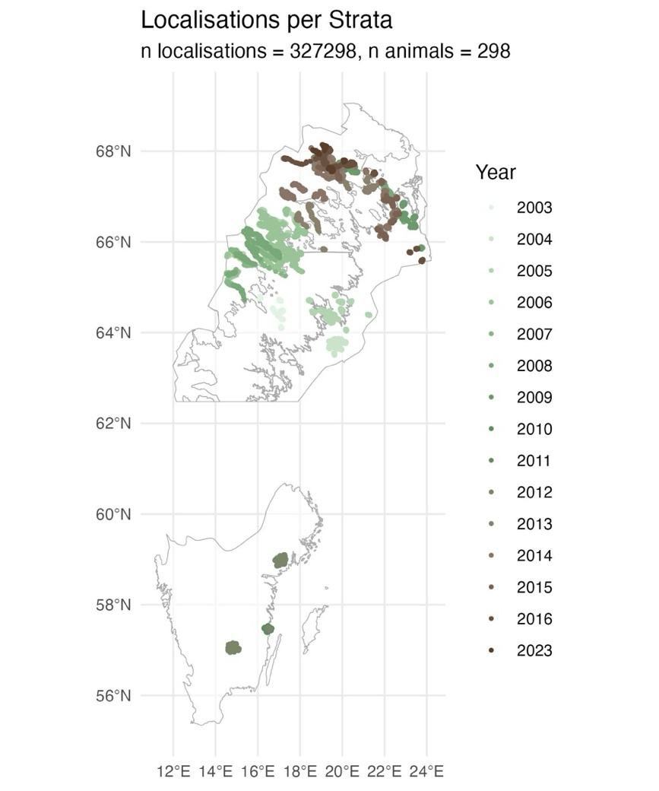
Following all filtering steps, the dataset consisted of 400,181 localizations from 300 individual moose. Because the data were aggregated from numerous historical studies, the distribution of localizations among strata was uneven. The proportions were as follows: Boreal Alpine accounted for 44 percent, Boreal Coastal for 14 percent, Boreal Inland for 8 percent, and Temperate for 28 percent. A visual representation of the strata and the annual distribution of moose localizations is provided in Figure 1.

Random Step Generation
For each observed movement step, fifteen random steps were generated using the amt package in R (Signer et al., 2019). This method allowed for the construction of a reference distribution against which selection could be inferred. Step lengths were modeled using a gamma distribution, while turning angles were modeled using a von Mises distribution. These distributional choices are widely accepted in the context of animal movement modeling and have been supported by previous research (Thurfjell et al., 2014).
Figure 1: All pre-processed moose localisations. Sweden is divided in four strata for this study, defined by grey lines in this figure. Boreal Alpine (top left), Boreal Inland (top middle), Boreal Coast (top right), and Temperate (south). The localisation’s color refers to the year it was obtained.
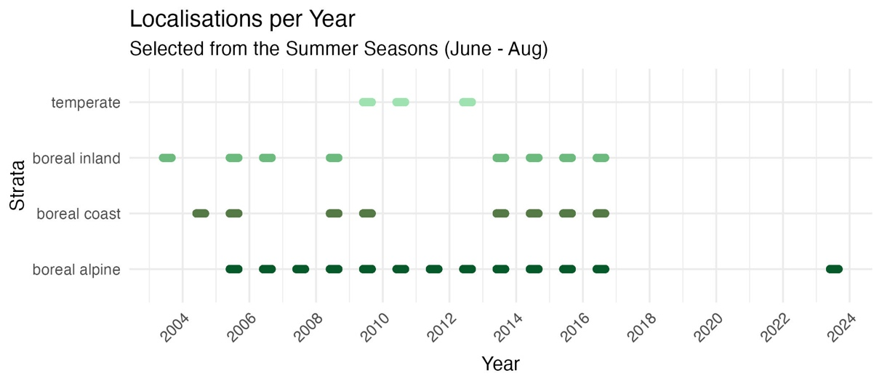
Figure 2: Localisations included within the four strata. Each dash represents a summer of moose localisations within that stratum.
Movement distributions were fitted separately for each stratum, treating each as a distinct population. This stratified approach was chosen because moose in the boreal strata differ in morphology and movement behavior compared to those inhabiting the temperate stratum. These behavioral and ecological differences were evident in the resulting fitted distributions, which varied in their parameters across strata.

Sampling Geographical Covariates
Each localization was annotated with a set of geographical covariates hypothesized to influence moose movement behavior during heatwaves. Covariates were selected either because they represented potential points of attraction, such as dense forests and clear-cut areas providing favorable foraging conditions, or potential points of repulsion, such as rugged. An overview of the covariates included in the analysis is provided in Table 1.
Land cover data were obtained from the Swedish Environmental Protection Agency's National Land Cover Database (Naturvårdsverket, 2003). Two datasets were used: one from 2003 with a spatial resolution of 25 m × 25 m, and one from 2018 onward with a spatial resolution of 10 m × 10 m. Land cover categories were simplified into eight classes: coniferous forest, deciduous and mixed forest, clear-cut and young forest, low-mountain forest, wetlands, open areas, water bodies, and anthropogenic land.
Because the land cover data represented snapshots in time, forestry changes that occurred after the publication dates of these datasets would not be captured, despite the importance of clear-cuts as foraging habitats for moose. To address this, forest felling data from the Swedish Forest Agency were incorporated to manually update the land cover maps (Skogsstyrelsen, 2024). Localizations that occurred within ten years after a recorded felling event were reassigned to the "clear-cut and young forest" land cover class.
The average distribution of land cover classes used by moose in each stratum between June and September is shown in Figure 3. Based on these distributions, it was observed that moose predominantly utilized three to four specific habitat types per stratum. Therefore, for each stratum, only these commonly used habitat classes were retained for modeling, while the remaining classes were combined into a single "other" category. This step was necessary to meet the requirements of the two-stage SSF modeling approach, which assumes that each individual animal has visited each habitat class included in the model at least once.

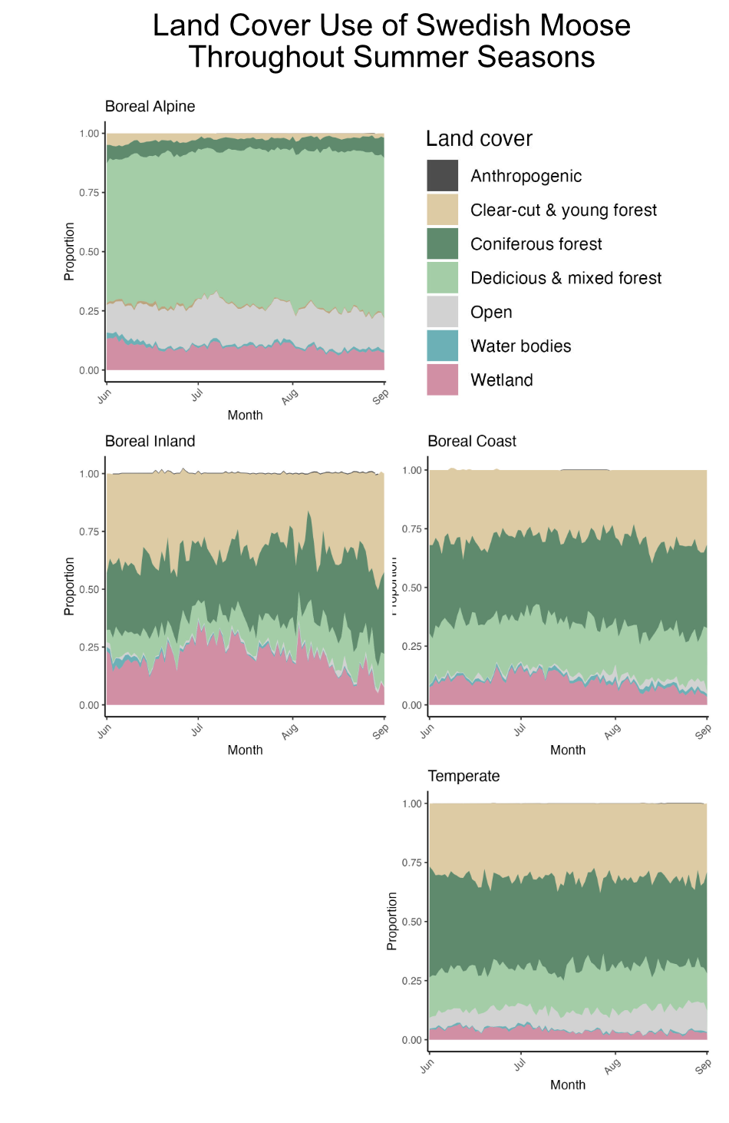
Figure 3: Proportions of land cover use by strata in the summer seasons, averaged over all years. For each strata, three or four land covers tend to dominate.
In addition to land cover, proximity to water sources was included as a covariate to investigate whether moose preferentially moved closer to water during heatwave conditions. A continuous raster layer of distances to the nearest water source was generated by applying the Proximity (Raster Distance) tool in QGIS to the water bodies layer derived from the land cover map (QGIS Development Team, 2025). Elevation was also included as an environmental covariate. Elevation data were obtained from Lantmäteriet (the Swedish mapping authority) at a spatial resolution of 50 m × 50 m (Lantmateriet, 2009). From these data, a terrain ruggedness index (TRI) was calculated following the method described by Riley et al. (1999) to quantify topographic heterogeneity, which has previously been shown to induce movement costs and influence habitat selection (Støen et al., 2010).

Name | Spatial Resolution | Year Origin | Source
Land cover, simplified into 7 classes | 25m x 25m & 10m x 10m | 2003 & 2018 (continuously updated) | The Swedish Environmental Protection Agency (Naturvårdsverket, 2003)
Elevation | 50m x 50m | 2015 | Lantmäteriet (Lantmateriet, 2009)
Terrain Ruggedness Index (Riley et al., 1999) | 50m x 50m | 2015 | Derived from DEM (Lantmateriet, 2009)
Distance to Water | 25m x 25 m | 2003 | Derived from land cover (using proximity raster distance in QGIS) (QGIS Development Team, 2025).
Table 1: Geographical covariates used within the step selection analysis.

Predicting Local Weather Through Space-Time Regression Kriging
To assess the effects of temperature extremes at fine spatial scales, several options for obtaining temperature data were considered: collar-derived sensors, the nearest weather station, and spatial interpolation methods. Collar-derived temperature data were ultimately rejected, as these sensors can produce outliers due to influences such as solar radiation, body heat, and wind exposure, limiting their interpretability for fine-scale environmental analysis. Although the use of the nearest weather station was also evaluated, this method was deemed inadequate for alpine and mountainous areas, where temperature varies strongly with elevation and local topography. As a result, space-time regression kriging was selected as the most suitable interpolation method. This approach allows for the incorporation of key predictors such as elevation, latitude, and day of the year, improving the representation of local temperature patterns over both space and time.

Data Collection and Regression Modeling
Weather data were obtained from the Swedish Meteorological and Hydrological Institute (SMHI) via their publicly available API (SMHI, 2022). A Python package was developed to request and store weather data automatically in a PostgreSQL database (Appendix 1) (PostgreSQL Global Development Group, 2024). Only weather stations with a "good" (G) quality rating, as indicated by the SMHI API, were included. Furthermore, to minimize spatial redundancy, stations located within 100 meters of another station were removed. Space-time regression kriging was implemented in R using the gstat and spacetime packages in R (Gräler et al., 2016; Pebesma, 2012), following the methodology described by Sekulić et al. (2020). The first step involved fitting a regression model to the weather station data collected across all summer seasons within the study period. Explanatory variables included the year of measurement, a second-degree orthogonal polynomial of elevation, and the Geometric Temperature Trend (GTT), a variable that predicts daily mean temperature based on latitude and day of the year (Sekulić et al., 2020). This regression model captured the broad spatial and temporal trends in temperature before kriging was applied to model the local residual variation.

Kriging Procedure
Following regression, space-time kriging was performed on the residuals to capture localized deviations from the large-scale temperature trend. Data pre-processing, variogram fitting, and kriging were implemented using the gstat and spacetime packages (Gräler et al., 2016; Pebesma, 2012). The sum-metric space-time variogram model in gstat was used in order to model the spatial-temporal variability (Gräler et al., 2016). Given the large volume of temperature observations, it was not computationally feasible to generate a single experimental semi-variogram for all available data. Space-time kriging is computationally intensive, with cubic time complexity, meaning that a tenfold increase in data points leads to a thousandfold increase in computation time (Yang et al., 2022). To balance computational feasibility with the need to capture short-term temperature variability, kriging was performed on a weekly basis. Weekly aggregation allowed the model to remain sensitive to short-term fluctuations, such as heatwaves, while ensuring that computational load remained manageable. Empirical and theoretical variograms were fitted separately for each week based on the residuals of the regression model. A small nugget effect was included to mitigate the screening effect and possible small scale temperature fluctuations, as some weather stations remained relatively close even after the filtering step. Kriging was performed directly at the moose localization points rather than across a general prediction grid, targeting the specific locations of interest. No unrealistic temperature outliers were observed in the kriging outputs.

Model Validation
Model performance was evaluated using K-fold cross-validation. For each week, the weather station data were randomly divided into five folds, creating distinct training and validation sets. This procedure allowed the model to be tested across both spatial and temporal dimensions, offering a more thorough validation than methods based solely on spatial holdout, such as omitting entire stations. Although SMHI stations varied in their sampling frequency (with some recording hourly and others every three hours), the absence of significant temporal gaps in the data made K-fold cross-validation appropriate.
A summary of the regression model and kriging validation results is provided in the Results section, while full details are presented in Appendix 1.

Step Selection Functions
For each stratum, a Step Selection Function (SSF) model was created to investigate habitat selection by moose. For model fitting I used the clogit function from the survival package (Therneau, 2024) in R. Two separate models were fitted: one based on localizations that occurred during heatwaves and one based on localizations outside of heatwaves. Heatwaves were defined using biological extremes rather than climatological thresholds, as the precise onset of heat stress in moose remains debated (Thompson et al., 2020). Specifically, a heatwave was defined as a period of three or more consecutive days in which the daily maximum temperature exceeded the 75th percentile of the available moose temperature data within each stratum. This cutoff was chosen as higher percentiles reduced the number of qualifying steps, making it less likely that each habitat category was represented across individuals. Nonetheless, higher percentiles may yield stronger behavioral responses if sample size permits.
Model Covariates
Movement-related variables were included to account for the underlying movement process and to construct an integrated step selection function. These consisted of step length, its logarithm, and turning angle. Environmental variables were included at the end of each step and consisted of land cover, distance to the nearest water body, and elevation. Each of the environmental covariates was given an interaction with the temperature at the end of the step to investigate how habitat selection varied as a function of thermal conditions. End-step temperatures were used instead of start-step temperatures because GPS localizations occurred at relatively coarse temporal intervals of approximately three hours. With such intervals, substantial environmental changes can occur along the step trajectory, making the end-point conditions a better approximation of the microenvironment ultimately selected by the animal. This ensured that modeled selection reflected actual conditions at the chosen location rather than at the beginning of the movement path.
In addition to temperature interactions, harmonic terms were included to account for cyclical daily patterns. Two pairs of sine and cosine terms were used to model time-of-day effects, one pair for the start of the step and one for the end. Following formula 3.2 with $j=1$ for one pair and $j=2$ for the second pair. These were interacted with both environmental and movement variables to allow selection to vary over the course of the day. Following Signer et al. (2019), the movement terms were interacted with harmonic terms calculated at the start of each step to investigate how the animal’s current conditions influence movement. In contrast, interactions for habitat-related variables used harmonic terms at the end of the step, as the aim was to assess habitat selection based on the conditions in the area to which the animal moved (i.e. selected for).
Tertiary interactions among environmental variables, time of day, and temperature were not included, as heatwave and non-heatwave conditions were already analyzed separately through distinct models. All variables were tested for collinearity using the Generalized Variance Inflation Factor (GVIF), adjusted for degrees of freedom, which found GVIF being < 2 for all variables.

Model Fitting
Models were fitted using a two-step approach. First, an SSF was fitted separately for each individual moose, without random effects. Second, population-level inference was obtained by aggregating individual coefficients through an intercept-only linear regression (Eq. 8). Each coefficient was weighted by the inverse of its variance in order to reduce the effect of outliers and animals with few localizations for specific categories (Naturvårdsverket, 2003)

$$\begin{aligned}fit=lm\left(coef∼1, weights=inv_{var}\right)\#\left(8\right)\end{aligned}$$
The full model formula for individual-level fits is illustrated below (Eq. 9):
$$\begin{aligned}\text{case}∼ \#\left(9\right)\end{aligned}$$
$$\underset{\text{Main habitat terms}}{\underbrace{\text{landuse}\text{_}\text{end}+\text{dist}\text{_}\text{to}\text{_}\text{water}\text{_}\text{end}+\text{elevation}\text{_}\text{end}}}+$$
$$\underset{\text{Terrain cost term}}{\underbrace{\text{ruggedness}\text{_}\text{end}}}+$$
$$\underset{\text{Movement terms}}{\underbrace{\text{sl}+\log\left(\text{sl}\right)+\cos\left(\text{ta}\right)}}+$$
$$\underset{\text{Habitat × time interactions}}{\underbrace{\begin{aligned}\left(\text{landuse}\text{_}\text{end}+\text{dist}\text{_}\text{to}\text{_}\text{water}\text{_}\text{end}+\text{elevation}\text{_}\text{end}\right): \\ \left(\text{hour}\text{_}\text{s1}\text{_}\text{t2}+\text{hour}\text{_}\text{c1}\text{_}\text{t2}+\text{hour}\text{_}\text{s2}\text{_}\text{t2}+\text{hour}\text{_}\text{c2}\text{_}\text{t2}\right)\end{aligned}}}+$$
$$\underset{\text{Movement × time interactions}}{\underbrace{\begin{aligned}\left(\text{sl}+\log\left(\text{sl}\right)+\cos\left(\text{ta}\right)\right): \\ \left(\text{hour}\text{_}\text{s1}\text{_}\text{t1}+\text{hour}\text{_}\text{c1}\text{_}\text{t1}+\text{hour}\text{_}\text{s2}\text{_}\text{t1}+\text{hour}\text{_}\text{c2}\text{_}\text{t1}\right)\end{aligned}}}+$$
$$\underset{\text{Stratified matched design}}{\underbrace{\text{strata}\left(\text{step}\text{_}\text{id}\right)}}$$
Equation 9: Model used for integrated step selection analysis. Habitat selection and movement were modeled using main effects (e.g. land cover, elevation), movement terms (step length, log-transformed step length, and cosine of turning angle), and interactions with time of day (harmonic terms). Harmonic terms were constructed using sine and cosine transformations of the time of day at both the start (*_t1) and end (*_t2) of each step. Terms of the form hour_s1_t2, hour_c2_t1, etc., represent sinusoidal transformations with 2 cycles per 24 hours, enabling the model to capture diel activity rhythms and their influence on both movement and habitat selection.

Results

Heatwave events
To identify periods of thermal stress, heatwaves were defined as three or more consecutive days during which the maximum daily temperature in a stratum exceeded the 75th percentile of all recorded temperatures during the study period. Based on this threshold, the Boreal Alpine stratum experienced the greatest number of heatwave days (n = 209), followed by the Boreal Inland (n = 143) and Boreal Coast (n = 124) strata. The distribution of GPS localizations available for analysis during heatwave and control conditions is shown in Table 2.

Figure 4: Daily maximum temperature throughout the study period for each climatic stratum. Heatwave periods, defined as three or more consecutive days above the 75th percentile of maximum temperature, are highlighted in red. Separate panels show data from the Boreal Alpine, Boreal Inland, Boreal Coastal, and Temperate regions, illustrating spatiotemporal variation in temperature, frequency and timing of extreme heat events.
 | Boreal Alpine | Boreal Inland | Boreal Coast | Temperate
Control Dataset | 112936 | 17830 | 40168 | 78403
Heatwave Dataset | 34730 | 6160 | 9063 | 16554

Movement during heatwave events
Time-varying coefficients for step length, log-transformed step length, and turning angle revealed distinct circadian patterns across climatic strata (Figure 5). Across all regions, selection for longer step lengths decreased around dawn and dusk, suggesting reduced movement rates during these transitional periods. This pattern was consistent across heatwave and control conditions. In contrast, midday periods showed minimal selection for either longer or shorter steps, indicating more neutral movement behavior.
During nighttime hours, however, a shift emerged. Selection for longer step lengths increased markedly, particularly during heatwave events. This heightened selection for movement at night suggests a potential behavioral compensation for daytime thermal constraints, enabling individuals to maintain activity levels while avoiding heat stress. Patterns in the log-transformed step length coefficient further supported this interpretation. The rise in coefficient values later in the day corresponds to a broader gamma distribution of step lengths, indicating more variable movement behavior. In practical terms, this reflects a shift toward both longer and more dispersed steps, a strategy likely linked to altered foraging or thermoregulatory behavior under heat stress.
In contrast, turning angle exhibited minimal influence on step selection across all strata, with no discernible circadian rhythm or differentiation between control and heatwave periods. This suggests that directionality of movement was not strongly modulated by time of day or thermal conditions, unlike movement rate.

Figure 5: Time-varying step selection function coefficients for movement parameters across the 24-hour cycle. Each panel represents a climatic stratum. Colored lines show the effect of turning angle, log-transformed step length, and step length on step selection across hours of the day.

Land cover preference during heatwave events
Circadian patterns of habitat selection varied across climate strata and between control and heatwave conditions. In all models, selection was modeled relative to a baseline habitat type (the most commonly visited habitat in a strata), and coefficients represent the time-varying strength and direction of selection.

Boreal Alpine
During heatwave events, moose in the boreal alpine stratum showed a modest increase in selection for deciduous and mixed forests around midday (Figure 6). Wetland selection coefficients could not be estimated during heatwaves, as too few individuals visited these habitats. This likely reflects a behavioral shift away from wetlands under heat stress, possibly due to the lower availability of shade.
Figure 6: Time-varying habitat selection coefficients for the boreal alpine stratum. Lines represent selection for deciduous and mixed forests relative to coniferous forest across the 24-hour cycle. Wetland selection could not be estimated during heatwaves due to low visitation.

Boreal Inland
In the boreal inland stratum, moose displayed marked circadian rhythms in habitat selection under control conditions (Figure 7). Clear-cut and young forest was strongly selected during nocturnal and early morning hours, while coniferous forest and wetlands were consistently avoided. During heatwaves, these patterns shifted. The strong nocturnal preference for clear-cut areas disappeared, and coniferous forest and wetland habitats exhibited pronounced diurnal seasonality, with positive selection peaking during daylight hours. These shifts suggest a change in thermal or shelter-driven habitat use under elevated temperatures.
Figure 7: Time-varying habitat selection coefficients for the boreal inland stratum. Lines show selection for clear-cut and young forest, deciduous forest, mixed forest, and wetland relative to coniferous forest. Separate lines are shown for control and heatwave models.

Boreal Coast
Moose in the boreal coastal region exhibited similar patterns to those observed inland (Figure 8). Clear-cut and young forests were favored during crepuscular and nighttime hours under both control and heatwave conditions. However, heatwave conditions led to increased use of denser habitats (deciduous and coniferous forests) during twilight and nighttime hours, and reduced selection for clear-cut and mixed forests during midday. These behavioral shifts indicate greater use of thermally buffered habitats under elevated temperatures.
Figure 8: Time-varying habitat selection coefficients for the boreal coastal stratum. Lines represent relative selection for each habitat type across hours of the day. Note the increased selection for dense forest cover and reduced use of open habitats during heatwaves.

Temperate
In the temperate stratum, habitat selection patterns were relatively stable across conditions (Figure 10). All major habitat types, clear-cut, coniferous, and deciduous forests, exhibited peaks in selection around midday and late evening. Comparisons between control and heatwave models revealed only slight decreases in selection strength for clear-cut and coniferous forests during heatwaves, suggesting minimal behavioral adjustment in this region.

Figure 10: Time-varying habitat selection coefficients for the temperate stratum. Peaks in selection occur around midday and evening, with only minor differences between control and heatwave conditions.

Elevation and distance to water preference during heatwave events
Patterns of selection for elevation and distance to water varied across strata but revealed consistent thermal strategies (Figure 11). Across all climate strata, moose selected locations at lower elevations than their previous position, particularly around midday. This downward movement peaked during the warmest parts of the day and was amplified under heatwave conditions, suggesting an adaptive response to thermal stress by seeking lower terrain.
In the boreal alpine stratum, moose also showed positive selection for distance to water during daylight hours, meaning they tended to move away from water bodies during the day. This pattern may reflect an avoidance of open, exposed areas near water, which offer limited thermal cover. In contrast, no such clear daytime avoidance of water was observed in the other strata.

Figure 11: Time-varying step selection coefficients for elevation and distance to water across all four strata. Lines represent relative selection across the 24-hour cycle, with separate curves shown for control and heatwave models. Positive values indicate selection for greater elevation or distance to water relative to the previous location. Note the intensified selection for lower elevation during midday, especially under heatwave conditions.

Discussion & Conclusion
This study examined how Swedish moose respond to heatwave events using fine-scale movement and habitat data across varying ecological contexts. The results provide both support and nuance for the hypotheses posed, particularly in the context of behavioral thermoregulation, diel rhythmicity, and spatial habitat use.
The Heat-Avoidance Behavior Hypothesis was strongly supported. Moose adjusted their behavior during heatwaves, reducing movement during the hottest hours of the day and increasing activity at night. This aligns with prior observations that moose typically reduce daytime movement in response to heat stress and mirrors patterns of nocturnal compensation observed in other cold-adapted ungulates under warming conditions (Brivio et al., 2024; Jennewein et al., 2020)
In addition to movement patterns, habitat selection during heatwaves was affected in some strata. In the boreal inland strata, moose selected for forest over clear-cut and young forest in the middle of the day during heatwaves, consistent with their use as thermal refuge. Although such increased selection did not occur in the boreal coast strata, a decrease in selection for clear-cut and young forest was found. These behavioral adjustments are consistent with a thermoregulatory strategy in which moose trade foraging or exploration during daytime for thermal comfort in shaded microclimates, thereby affirming the presence of active heat-avoidance strategies.
The Circadian Rhythm Modulation Hypothesis was not strongly supported. Moose exhibited seasonality in their movement across all strata regardless of heatwaves occurring or not. The heatwave model did provide support for circadian rhythm being affected by temperature, with stronger seasonality in movement, even though the day-night cycle was absent. These results underscore the importance of analyzing behavioral responses across the full 24-hour cycle rather than relying on day, night binning. Importantly, the shift toward cooler periods occurred even in regions with prolonged daylight, suggesting that thermal cues can override photic entrainment of activity cycles.
Support for the Foraging Opportunity Hypothesis was limited. It was anticipated that moose would offset reduced daytime foraging by selectively using high-quality foraging habitats, such as clear-cuts or young forest stands, during cooler twilight periods. However, this pattern was not consistently observed across strata. Although moose did increase movement during evening and early morning hours, there was little consistent evidence of elevated selection for the preferred foraging habitat of clear-cut and young forest during those windows. This suggests either that thermal priorities override foraging priorities under extreme heat, or that the available land cover data were insufficiently detailed to detect such selection. Future work employing continuous habitat quality indices such as NDVI or LiDAR-derived structure could better resolve this question.
The Water-Seeking Behavior Hypothesis was not supported across the board. Although some prior studies have found that moose increase their use of wetlands and riparian areas during hot periods (e.g., Jennewein et al., 2020), the present analysis detected only sporadic or weak effects of proximity to water. In boreal alpine, moose even appeared to avoid wetland features under heat. One plausible explanation is the resolution of the spatial data: water availability was defined primarily through large rivers and lakes, which may not capture small-scale aquatic features that serve as thermal refuges. Without fine-scale hydrological data or information on ephemeral wetlands, it remains difficult to assess the full extent of water-seeking behavior during heatwaves.
Findings related to the Topographic Refuge Hypothesis were unexpected. The hypothesis predicted that moose in alpine regions would ascend to higher elevations during heatwaves to access cooler temperatures. Instead, moose consistently selected lower elevations at midday, and this tendency intensified with increasing temperature. Lower elevation areas in the study region often contained denser forest stands and richer vegetation. In addition, the energy expenditure and heat generation of moving uphill was also not considered when forming the hypothesis. Rather than prioritizing elevation itself as a thermal refuge, moose appeared to select habitats with greater structural buffering from solar radiation. This suggests that thermal priorities might override foraging priorities under extreme heat.
The results must be interpreted in light of several methodological limitations. The 3-hour fix rate of GPS collars may miss short-term adjustments or micro-behavioral shifts. The harmonic modeling framework used was constrained to two harmonic terms due to convergence issues, which may have limited the resolution of diel variability. Coarse habitat classification and lack of canopy-specific metrics may have further limited detection of habitat specificity. Additionally, modeling constraints, such as requiring moose to encounter each habitat type at each time point, reduced the sample size available for interaction effects. These constraints suggest caution in interpreting the exact magnitude of observed effects, even though the directionality appears robust.
I attempted at finding statistically significant changes in selection when carrying out the time-varying step selection functions. For this I incorporated an empirical bootstrap of the step selection function coefficients. However, when deriving the confidence intervals for the harmonic interaction terms, phase shifts in the circadian pattern between bootstrap replicates introduced challenges. In some resampled datasets, the timing of peak activity (the phase of the cosine/sine) shifted. This resulted in confidence intervals where lower and upper bounds for coefficients can swap, as the coefficients are cyclical. My limited experience with harmonic regression means I did not explore this further, but future work should focus on this limitation. Alternatively, recent studies have employed splines or hierarchical random effect models that do not encounter this issue, at the cost of computational time-complexity (Klappstein et al., 2024).

Conclusion
In conclusion, this study reveals that Swedish moose adjust their behavior during heatwaves by reducing daytime movement and increasing nocturnal activity, supporting the Heat-Avoidance Behavior Hypothesis. However, other hypotheses, such as those related to circadian rhythm, foraging, water-seeking, and topographic refuge, were only weakly supported or not observed as expected. These findings highlight the importance of thermal comfort over foraging and suggest that moose behavior is influenced more by habitat structure than elevation or proximity to water. Despite methodological limitations, the study underscores the need for fine-scale data and improved modeling techniques to better understand wildlife responses in high latitudinal areas to extreme weather events in a changing climate.

Recommendations
This study highlights several areas for improvement in future research. First, the use of three pairs of harmonics for modeling diel patterns resulted in convergence issues, as some animals did not visit all habitat types at every harmonic timestamp. This led to missing interaction terms, making two pairs the most reliable option. Future work should explore alternative methods, such as optimizing harmonic regression frameworks or employing longer GPS fix rates, to improve model stability and ensure all interaction terms are captured.
Regarding spatial resolution, the quality of the landcover maps used in this study was limited. While an attempt was made to work with available data, future studies should incorporate more detailed remote sensing-derived indices, such as NDVI (Normalized Difference Vegetation Index), to better capture habitat characteristics that are crucial for understanding moose behavior. In general focus should be put on using continuous variables (Beltran & Tarwater, 2024). Additionally, high-resolution LiDAR or satellite-based vegetation structure data would provide a more accurate representation of habitat features, improving the ability to detect subtle behavioral patterns in response to heat stress.
The bootstrapping method used for calculating confidence intervals was challenged by phase shifts, particularly when deriving harmonic term interaction effects. To address this, alternative methods like splines or hierarchical random effect models could better accommodate cyclical data and improve the accuracy of confidence intervals. These models would allow for better resolution of temporal dynamics.
Finally, future studies should consider anchoring time by daylight length when analyzing circadian rhythms, particularly in high-latitude regions with significant variation in daylight duration (Vazquez et al., 2019). Adjusting for daylight length would improve the accuracy of behavioral models across different seasons and better account for the influence of photoperiod on moose activity patterns.
Incorporating these improvements will help refine our understanding of moose behavior in response to extreme weather events and provide more robust data for wildlife management in a changing climate.

References
Bayer, M. (2024). SQLAlchemy: The Database Toolkit for Python. https://www.sqlalchemy.org
Beltran, R. S., & Tarwater, C. E. (2024). Overcoming the pitfalls of categorizing continuous variables in ecology, evolution and behaviour. Proceedings of the Royal Society B: Biological Sciences, 291(2032), 20241640. https://doi.org/10.1098/rspb.2024.1640
Brivio, F., Apollonio, M., Anderwald, P., Filli, F., Bassano, B., Bertolucci, C., & Grignolio, S. (2024). Seeking temporal refugia to heat stress: Increasing nocturnal activity despite predation risk. Proceedings of the Royal Society B: Biological Sciences, 291(2015). https://doi.org/10.1098/rspb.2023.1587
Bump, J. K., Bergman, B. G., Schrank, A. J., Marcarelli, A. M., Kane, E. S., Risch, A. C., & Schütz, M. (2017). Nutrient release from moose bioturbation in aquatic ecosystems. Oikos, 126(3), 389–397. https://doi.org/10.1111/oik.03591
Chatterjee, N., Wolfson, D., Kim, D., Velez, J., Freeman, S., Bacheler, N. M., Shertzer, K., Taylor, J. C., & Fieberg, J. (2024). Modelling individual variability in habitat selection and movement using integrated step-selection analysis. Methods in Ecology and Evolution, 15(6), 1034–1047. https://doi.org/10.1111/2041-210X.14321
Cressie, N. A. C., & Wikle, C. K. (2011). Statistics for spatio-temporal data. Wiley.
Dettki, H., Ericcson, G., Giles, T., & Norrsken-Ericsson, M. (2013). Wireless Remote Animal Monitoring (WRAM)—A new international database e-infrastructure for telemetry sensor data from fish and wildlife. In Proceedings Etc. 2012: Convention for Telemetry, Test Instrumentation and Telecontrol (pp. 247–256). The European Society of Telemetry.
Dussault, C., Ouellet, J.-P., Courtois, R., Huot, J., Breton, L., & Larochelle, J. (2004). Behavioural responses of moose to thermal conditions in the boreal forest. Écoscience, 11(3), 321–328.
Ericsson, G., Dettki, H., Neumann, W., Arnemo, J. M., & Singh, N. J. (2015). Offset between GPS collar-recorded temperature in moose and ambient weather station data. European Journal of Wildlife Research, 61(6), 919–922. https://doi.org/10.1007/s10344-015-0968-7
Fieberg, J., Matthiopoulos, J., Hebblewhite, M., Boyce, M. S., & Frair, J. L. (2010). Correlation and studies of habitat selection: Problem, red herring or opportunity? Philosophical Transactions of the Royal Society B: Biological Sciences, 365(1550), 2233–2244. https://doi.org/10.1098/rstb.2010.0079
Fieberg, J., Signer, J., Smith, B., & Avgar, T. (2021). A ‘How to’ guide for interpreting parameters in habitat-selection analyses. Journal of Animal Ecology, 90(5), 1027–1043. https://doi.org/10.1111/1365-2656.13441
Forrest, S. W., Pagendam, D., Bode, M., Drovandi, C., Potts, J. R., Perry, J., Vanderduys, E., & Hoskins, A. J. (2025). Predicting fine-scale distributions and emergent spatiotemporal patterns from temporally dynamic step selection simulations. Ecography, 2025(2), e07421. https://doi.org/10.1111/ecog.07421
Gräler, B., Pebesma, E., & Heuvelink, G. (2016). Spatio-Temporal Interpolation using gstat. The R Journal. https://digitalcommons.unl.edu/r-journal/526
Hengl, T., Heuvelink, G. B. M., & Rossiter, D. G. (2007). About regression-kriging: From equations to case studies. Computers & Geosciences, 33(10), 1301–1315. https://doi.org/10.1016/j.cageo.2007.05.001
Jennewein, J. S., Hebblewhite, M., Mahoney, P., Gilbert, S., Meddens, A. J. H., Boelman, N. T., Joly, K., Jones, K., Kellie, K. A., Brainerd, S., Vierling, L. A., & Eitel, J. U. H. (2020). Behavioral modifications by a large-northern herbivore to mitigate warming conditions. Movement Ecology, 8(1), 39. https://doi.org/10.1186/s40462-020-00223-9
Klappstein, N. J., Michelot, T., Fieberg, J., Pedersen, E. J., & Mills Flemming, J. (2024). Step selection functions with non-linear and random effects. Methods in Ecology and Evolution, 15(8), 1332–1346. https://doi.org/10.1111/2041-210X.14367
Langrock, W. Z., Iain L. MacDonald, Roland. (2016). Hidden Markov Models for Time Series: An Introduction Using R, Second Edition (2nd ed.). Chapman and Hall/CRC. https://doi.org/10.1201/b20790
Lantmateriet. (2009). Swedish Digital Elevation Model [Dataset]. www.lantmateriet.se
Lenarz, M. S., Nelson, M. E., Schrage, M. W., & Edwards, A. J. (2009). Temperature Mediated Moose Survival in Northeastern Minnesota. The Journal of Wildlife Management, 73(4), 503–510. https://doi.org/10.2193/2008-265
Mawer, R., Bruneel, S. P., Pauwels, I. S., Elings, J., Pickholtz, E., Pickholtz, R., Schneider, M., Coeck, J., & Goethals, P. L. M. (2023). Individual variation in the habitat selection of upstream migrating fish near a barrier. Movement Ecology, 11(1), 49. https://doi.org/10.1186/s40462-023-00414-0
McClintock, B. T., & Michelot, T. (2018). momentuHMM: R package for generalized hidden Markov models of animal movement. Methods in Ecology and Evolution, 9(6), 1518–1530. https://doi.org/10.1111/2041-210X.12995
Messeri, A., Becciolini, V., Messeri, G., Morabito, M., Crisci, A., Orlandini, S., & Ponzetta, M. P. (2019). Wild ungulates and environmental temperature: Analysis on the possible utilization of data from sensor placed on GPS collars. International Journal of Biometeorology, 63(3), 293–300. https://doi.org/10.1007/s00484-018-01662-1
Montero, J.-M., Fernández-Avilés, G., & Mateu, J. (2015). Spatial and Spatio-Temporal Geostatistical Modeling and Kriging. John Wiley & Sons.
Montgomery, R. A., Redilla, K. M., Moll, R. J., Van Moorter, B., Rolandsen, C. M., Millspaugh, J. J., & Solberg, E. J. (2019). Movement modeling reveals the complex nature of the response of moose to ambient temperatures during summer. Journal of Mammalogy, 100(1), 169–177. https://doi.org/10.1093/jmammal/gyy185
Muff, S., Signer, J., & Fieberg, J. (2020). Accounting for individual-specific variation in habitat-selection studies: Efficient estimation of mixed-effects models using Bayesian or frequentist computation. Journal of Animal Ecology, 89(1), 80–92. https://doi.org/10.1111/1365-2656.13087
Naturvårdsverket. (2003). Nationella marktäckedata [Dataset]. https://www.naturvardsverket.se/verktyg-och-tjanster/kartor-och-karttjanster/nationella-marktackedata/
Pebesma, E. (2012). spacetime: Spatio-Temporal Data in R. Journal of Statistical Software, 51(7), 1–30.
PostgreSQL Global Development Group. (2024). PostgreSQL: The World’s Most Advanced Open Source Relational Database. https://www.postgresql.org
QGIS Development Team. (2025). QGIS Geographic Information System. QGIS Association. https://www.qgis.org
Renecker, L. A., & Hudson, R. J. (1989). Seasonal Activity Budgets of Moose in Aspen-Dominated Boreal Forests. The Journal of Wildlife Management, 53(2), 296–302. https://doi.org/10.2307/3801126
Research, R. (2024). PostGIS: Spatial and Geographic Objects for PostgreSQL. https://postgis.net
Riley, S. J., DeGloria, S. D., & Elliot, R. (1999). Index that quantifies topographic heterogeneity. Intermountain Journal of Sciences, 5(1–4), 23–27.
Sekulić, A., Kilibarda, M., Protić, D., Tadić, M. P., & Bajat, B. (2020). Spatio-temporal regression kriging model of mean daily temperature for Croatia. Theoretical and Applied Climatology, 140(1), 101–114. https://doi.org/10.1007/s00704-019-03077-3
Signer, J., Fieberg, J., & Avgar, T. (2019). Animal movement tools (amt): R package for managing tracking data and conducting habitat selection analyses. Ecology and Evolution, 9(2), 880–890. https://doi.org/10.1002/ece3.4823
Støen, O.-G., Neumann, W., Ericsson, G., Swenson, J., Dettki, H., Kindberg, J., & Nellemann, C. (2010). Behavioural response of moose Alces alces and brown bears Ursus arctos to direct helicopter approach by researchers. Wildlife Biology, 16, 292–300. https://doi.org/10.2981/09-041
Stokkan, K.-A., Van Oort, B. E. H., Tyler, N. J. C., & Loudon, A. S. I. (2007). Adaptations for life in the Arctic: Evidence that melatonin rhythms in reindeer are not driven by a circadian oscillator but remain acutely sensitive to environmental photoperiod. Journal of Pineal Research, 43(3), 289–293. https://doi.org/10.1111/j.1600-079X.2007.00476.x
Swedish Forest Agency (Skogsstyrelsen). (2024). Digital Open Forest Data. https://www.skogsstyrelsen.se/en/digital-open-forest-data/
Swedish Meteorological and Hydrological Institute (SMHI). (2022). SMHI Open Data API documentation: Meteorological observations. https://opendata.smhi.se/apidocs/metobs/
Team, T. P. D. (2024). PostGIS: Spatial and Geographic Objects for PostgreSQL. https://postgis.net
Therneau, T. M. (2024). A Package for Survival Analysis in R. https://CRAN.R-project.org/package=survival
Thompson, D. P., Crouse, J. A., Jaques, S., & Barboza, P. S. (2020). Redefining physiological responses of moose (Alces alces) to warm environmental conditions. Journal of Thermal Biology, 90, 102581. https://doi.org/10.1016/j.jtherbio.2020.102581
Thurfjell, H., Ciuti, S., & Boyce, M. S. (2014). Applications of step-selection functions in ecology and conservation. Movement Ecology, 2(1), 4. https://doi.org/10.1186/2051-3933-2-4
van Beest, F. M., & Milner, J. M. (2013). Behavioural responses to thermal conditions affect seasonal mass change in a heat-sensitive northern ungulate. PloS One, 8(6), e65972. https://doi.org/10.1371/journal.pone.0065972
van Beest, F. M., Van Moorter, B., & Milner, J. M. (2012). Temperature-mediated habitat use and selection by a heat-sensitive northern ungulate. Animal Behaviour, 84(3), 723–735. https://doi.org/10.1016/j.anbehav.2012.06.032
van Oort, B. E. H., Tyler, N. J. C., Gerkema, M. P., Folkow, L., Blix, A. S., & Stokkan, K.-A. (2005). Circadian organization in reindeer. Nature, 438(7071), 1095–1096. https://doi.org/10.1038/4381095a
Vazquez, C., Rowcliffe, J. M., Spoelstra, K., & Jansen, P. A. (2019). Comparing diel activity patterns of wildlife across latitudes and seasons: Time transformations using day length. Methods in Ecology and Evolution, 10(12), 2057–2066. https://doi.org/10.1111/2041-210X.13290
Verzuh, T. L., Rogers, S. A., Mathewson, P. D., May, A., Porter, W. P., Class, C., Knox, L., Cufaude, T., Hall, L. E., Long, R. A., & Monteith, K. L. (2023). Behavioural responses of a large, heat‐sensitive mammal to climatic variation at multiple spatial scales. Journal of Animal Ecology, 92(3), 619–634. https://doi.org/10.1111/1365-2656.13873
Yang, Y., Wang, P., & Brandenberg, S. J. (2022). An algorithm for generating spatially correlated random fields using Cholesky decomposition and ordinary kriging. Computers and Geotechnics, 147, 104783. https://doi.org/10.1016/j.compgeo.2022.104783

Appendix 1 – Sampling Temperature with Space-Time Regression Kriging

SMHI Mock Database
To efficiently handle large volumes of weather data, I implemented a database layer between the client and the SMHI API . This layer minimizes redundant API requests and allows for faster querying during analysis. The backend is powered by PostgreSQL 16, extended with PostGIS to manage spatial vector data. PostgreSQL was chosen for its performance, scalability, and strong support for spatial operations. Data ingestion and querying were handled using Python. I used the requests library to communicate with the SMHI API, and SQLAlchemy to interface with the PostgreSQL database (Vazquez et al., 2019). This setup allowed me to seed the database with all available SMHI stations once, thereby eliminating the need for repeated API calls during subsequent analyses. Most weather stations in the database recorded temperature either hourly or every three hours. Three-hour intervals were more common in the earlier years of the study period, whereas hourly recordings became more frequent in later years.

Linear Regression Model
As the first step in the kriging workflow, I fitted a linear regression model using all available summer weather data from the study period (2004–2023). This model served to extract residuals that could be interpolated using kriging. The explanatory variables included elevation, the year of measurement, and Growing Temperature Threshold (GTT), which was calculated using the r-meteo package based on latitude and day of the year. The model accounted for 26.4 percent of the variation in temperature across the temporal window of interest. To assess whether a linear relationship was appropriate, I inspected a Q-Q plot of the residuals. The plot showed approximate normality, with only minor deviations at the higher end of the distribution. This indicated that the model's assumptions were reasonably satisfied. The coefficients of the regression model are shown in Table 1. Elevation had a small but consistent negative effect on temperature, while GTT showed a strong positive relationship. Yearly effects were significant across the entire range, except for the year 2022.

Variable name | B Estimate | Std.Error | P-value
(Intercept) | 6.717 | 1.627e-02 | <2e-16 ***
elevation | -5.533e-03 | 8.039e-06 | <2e-16 ***
gtt | 7.387e-01 | 8.507e-04 | <2e-16 ***
Year 2004 till Year 2023 | (,) | (,) | All <2e-16 ***  except 2022 (0.593)

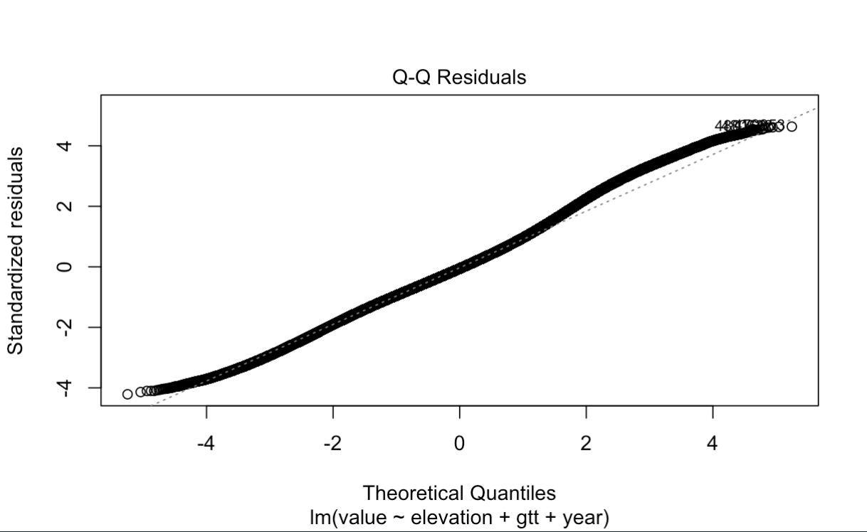

Semi-variogram Fitting
To address the computational demands of kriging, which has cubic time complexity, I divided the dataset into weekly intervals. This allowed me to run separate variogram models on each week, reducing memory and processing requirements. Across the different summer weeks I examined, I did not observe major differences in the fitted variograms. While this conclusion is based on visual inspection rather than formal testing, the same parameter values appeared to fit reasonably well throughout the summer period. This suggests that, although the underlying process may not be strictly stationary, the variogram model and parameters were consistently applicable to the data used. For illustration, I present the results for the week of 1 June to 7 June 2018. An empirical variogram was fitted using the spacetime package in R. I used this variogram to derive initial parameters for the model variogram (see Table 2). A small nugget effect was included for both the spatial and temporal dimensions. This decision was made to counteract the screening effect caused by the close proximity of some weather stations, which occasionally led to negative kriging weights. I then fitted a model variogram based on these initial values. The results of this fitted model are presented in Table 3.
 | Partial-sill | Range | Nugget
Space | 6 | 550000 | 0.001
Time | 30 | 10 | 0
Joint | 4 | 50000 | 0.001

 | Partial-sill | Range | Nugget
Space | 6.4286891 | 550000 | 0.3684194
Time | 299.3258 | 193.5573 | 0
Joint | 0.001 | 50000 | 0.001

It should be noted I did not perform a full sensitivity analysis to optimize starting values or parameter bounds. Instead, I selected a model that consistently converged and provided a good empirical fit. The sum-metric variogram model proved to be the most stable across different weeks and appeared well-suited to summer temperature data. For those planning to apply this methodology in other contexts, it is worth noting that I encountered more difficulty fitting variogram models to winter temperature data. In these cases, adjustments to the initial parameter values were often required to obtain a reasonable fit. While this was not central to my study, it may be an important consideration for future applications.

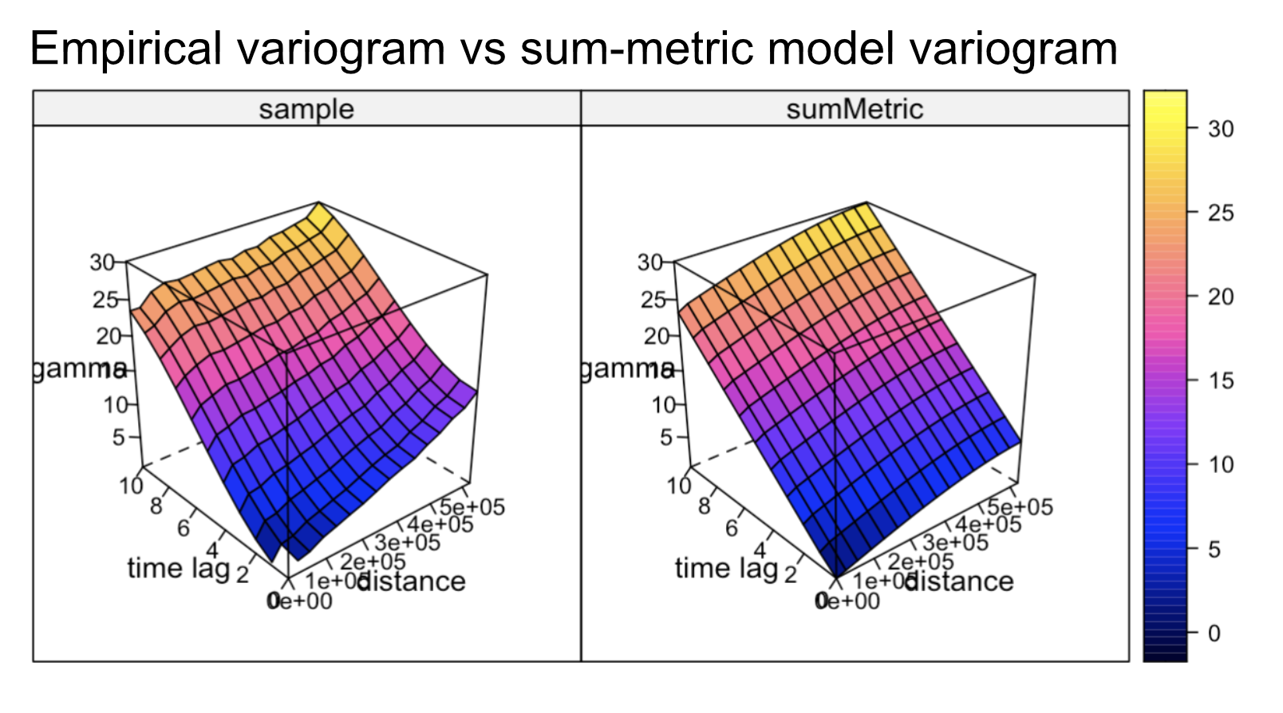

Cross Validation
To evaluate the accuracy of the space-time regression kriging model, I conducted a five-fold cross-validation. This involved dividing the weather dataset into five parts, training the model on four parts, and testing on the remaining one, cycling through all combinations. The model consistently explained approximately 96 percent of the variance in the held-out data across all folds. Mean absolute error was 0.96, and root mean square error was 1.36. These low error values indicate that the model has sufficient precision for the purposes of this study, where small deviations of a 1 or 2 degrees Celsius are unlikely to influence the overall results meaningfully.
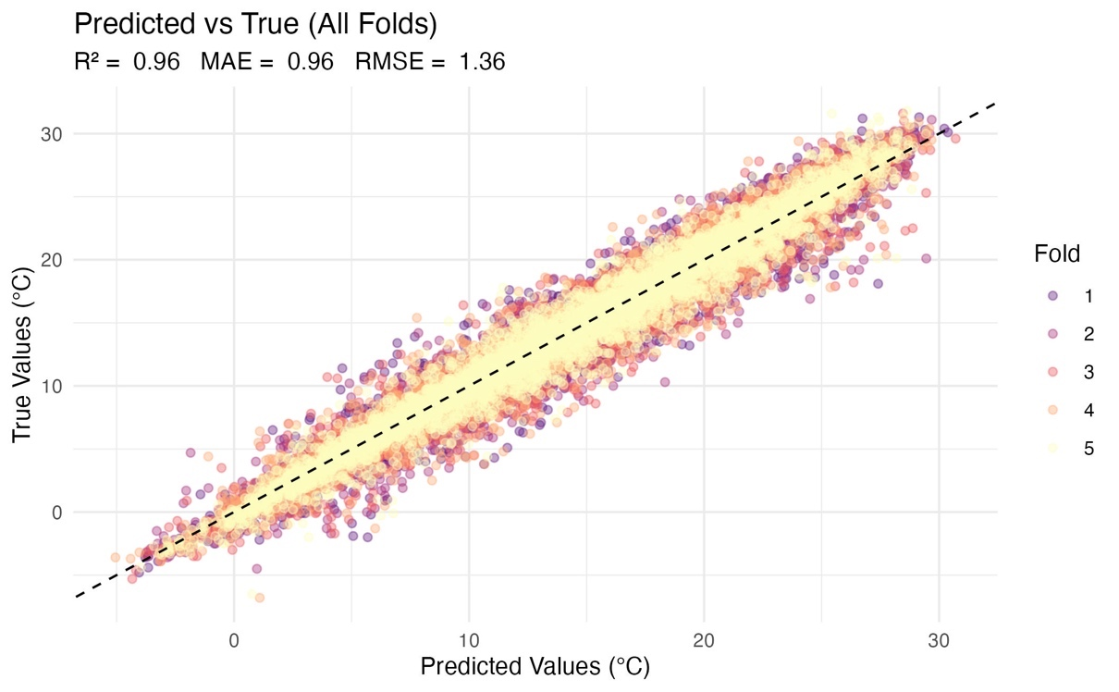

Predicitng Temperature at Moose Localisations
To estimate temperature at the locations of moose and random steps, I split the data into weekly batches. For each batch, I retrieved the corresponding week of weather data from the database, applied the linear regression model, fitted the variogram (using the same initial values as above), and then performed kriging. This was done independently for each batch, using the residuals from the regression as input for kriging. The entire process was parallelised using the parabar package.

Hardware Details
Kriging computations were parallelized using the parabar package and conducted on a virtual machine hosted on DigitalOcean, with 48 CPU cores allocated. Parallellisation significantly reduced runtime for the most computationally expensive parts of the workflow. Annotating temperature at moose localisations using space-time regression kriging required approximately 20 hours. This step was one of the most resource-intensive components of the entire analysis.

Appendix 2 – Code Availability
Quarto notebooks including explanations of the methodology and reproduction steps can be found at https://github.com/Shmuppel/moose-temperature-ssf: view the README.md for help setting up the environment. All spatial data used for analysis was kept in the coordinate reference system SWEREF-99 (EPSG:3006).

